MAJOR PROJECT VALIDATION FORM

Supervisor Name |  | Panel Head
 | Dr. Prabhu Chakkaravarthy
 | Faculty Advisor | Project Domain
 | Dr. Ushasukhanya | Artificial Intelligence / Machine Learning / Explainable AI / Healthcare Analytics
M
 | Student(s) Details: Name | Passport size photo(s)
 | - Vimal M | 
 | - Alfred Ferdinand

Registration Number(s)

1. RA2211028010217
2. RA2211028010232

Email ID(s)&Mobile Number(s)
1: vm5470@srmist.edu.in / 7603832537 | 2:

1 | Abstract | Non-communicable diseases (NCDs) such as diabetes, cardiovascular diseases, stroke, chronic kidney disease, and liver disorders account for a major portion of global morbidity and mortality. These diseases are strongly influenced by lifestyle and behavioral factors, yet most existing healthcare AI systems rely primarily on clinical parameters and function as black-box models, limiting trust and interpretability.  This project proposes an integrated Explainable Artificial Intelligence (XAI) framework for early risk assessment of lifestyle-induced NCDs using multimodal data fusion. The framework combines lifestyle, demographic, and clinical data through an ensemble learning approach and employs SHAP-based explainability to provide transparent, instance-level interpretations. The proposed system aims to support predictive and preventive healthcare by enabling trustworthy, interpretable, and scalable disease risk assessment.
2 | RESEARCH GAP  (not more than 3 points) | - Existing healthcare ML models are largely disease-specific and lack a unified multi-disease prediction framework.  - Limited integration of lifestyle and behavioral data with clinical parameters in disease risk assessment.  - Insufficient adoption of explainable AI techniques for transparent and trustworthy healthcare decision support.
3 | Please furnish the details of 5 research articles in IEEE Reference format with Impact factor and year of publication from Which Research gap has been identified (F. Lastname, “Title of article,” *Journal Name*, vol., no., pp., year. And IF 3.1)) / 5 Patent Details for highlighting the innovation | - L. Lundberg and S. Lee, “A Unified Approach to Interpreting Model Predictions,” Advances in Neural Information Processing Systems, vol. 30, pp. 4765–4774, 2017. (IF: 14.0)  - J. Chen et al., “Explainable Machine Learning for Healthcare: A Review,” IEEE Access, vol. 8, pp. 219032–219051, 2020. (IF: 3.9)  - Rajkomar et al., “Machine Learning in Medicine,” New England Journal of Medicine, vol. 380, no. 14, pp. 1347–1358, 2019. (IF: 176.0)  - S. Ahmad et al., “Ensemble Learning Approaches for Disease Prediction,” IEEE Journal of Biomedical and Health Informatics, vol. 24, no. 6, pp. 1757–1767, 2020. (IF: 7.7)  - WHO, “Non-Communicable Diseases and Artificial Intelligence,” WHO Technical Report, 2022.
4 | Bridging the Research Gap/ Innovation Gap  (not more than 3 points) | - Proposes a unified framework capable of predicting multiple lifestyle-induced NCDs.  - Integrates multimodal lifestyle, demographic, and clinical data.  - Embeds explainable AI (SHAP) as a core component for transparency and trust.
5 | OBJECTIVE  (not more than 5 points) | - To design a multimodal data fusion pipeline for healthcare datasets.  - To develop an ensemble-based disease risk prediction engine.  - To integrate explainable AI techniques for model interpretability.  - To support early risk assessment for multiple NCDs.  - To validate the framework using publicly available datasets.
6 | System Architecture | 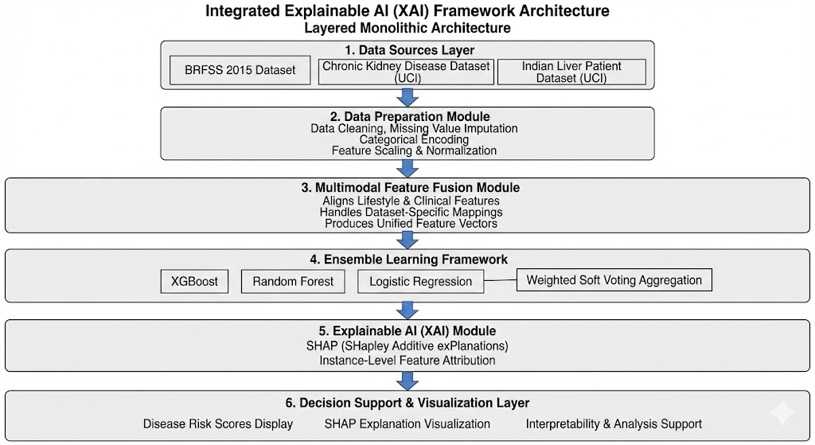
7 | METHODOLOGY  (not more than 10 points) | - Collection of publicly available healthcare datasets.  - Data cleaning and preprocessing.  - Missing value imputation and feature encoding.  - Feature normalization and scaling.  - Multimodal feature fusion.  - Ensemble model training (XGBoost, Random Forest, Logistic Regression).  - Handling class imbalance using SMOTE.  - Risk prediction using weighted soft voting.  - Explainability using SHAP.  - Result analysis and visualization.
8 | OUTCOMES OR DELIVERABLES  (not more than 5 points) | - Explainable AI framework for early disease risk assessment.  - Ensemble-based predictive models for multiple NCDs.  - SHAP-based interpretability outputs.  - Research publication / patent submission.  - Complete project documentation.
9 | NOVELTY  (not more than 3 points) | - Unified multi-disease risk assessment framework.  - Integration of lifestyle data with clinical parameters.  - Explainability-first healthcare AI design.
10 | Time line | Deliverables
 | November 2025(Review 0) | - Problem identification  - Literature survey  - Dataset analysis
 | January 2026 (SPRINT Review 1) | - Architecture design  - Partial implementation  - Initial research paper draft
 | March 2026 (SPRINT Review 2) | - Full model implementation  - Evaluation and explainability
 | April 2026 (SPRINT Review 3) | - Final validation  - Publication / patent submission  - Final project submission
11 | Collaboration details | - Academic collaboration with project guide.  - Use of publicly available research datasets.
12 | Target Technology Readiness Level of the project  (TRL Scale 1 to 9)  TRL 1 -Basic principles observed and reported.  TRL 2 -Technology concept formulated.  TRL 3 -Experimental proof of concept.  TRL 4- Technology validated in lab.  TRL 5- Technology validated in a relevant environment.  TRL 6 -Technology demonstrated in a relevant environment.  TRL 7- System prototype demonstration in operational environment.  TRL 8- System complete and qualified.  TRL 9- Actual system proven in operational environment. | TRL 3 – Experimental proof of concept (at Review-1)  Target by final review: TRL 4 – Technology validated in lab
13 | Sustainable Development Goal (1-17) ( Most prominent one goal) | SDG 3 – Good Health and Well-Being
14 | Industry Practice followed for system development ( Agile- SCRUM) | Agile Methodology – SCRUM (Research-oriented adaptation)

Conference/Journal Publication/Patent Details (Mandatory, Target Publication a)
Annals of R.S.C.B., ISSN:1583-6258, Vol. 25, Issue 6, 2023

Signature of Students: 1.
2.

Signature of the Supervisor:

